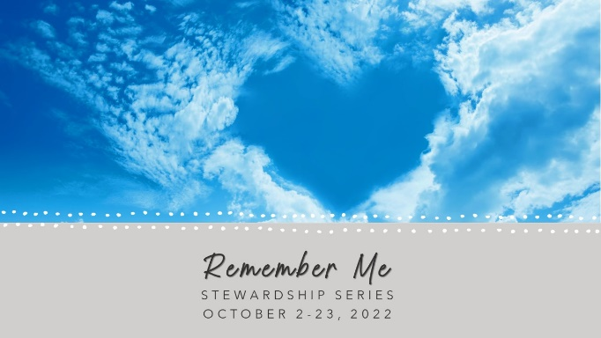
MY COMMITMENT FOR 2023

Walled Lake United Methodist Church

In gratitude for the blessings of God and to sustain and advance God’s work, I/we commit to the following:

€ Prayers
€ Presence
€ Service
€ Witness

€ Gifts
____Weekly

____Monthly

____Yearly
(Check one)

General Fund $________________

Major Repairs $________________

Name: _____________________________________________ Mission of Month $_____________

Pledges can be changed at any time. For giving questions, contact Linda Nielsen, Financial Secretary, at 248-421-3412.

