MOBILITY WORLDWIDE
SUPPLIES NEEDED:
Contribute during the month of June

TOOLS
6" Adjustable Wrench
6" Locking Pliers/Vice Grips
7/16" Combination Wrenches

PAINT SUPPLIES
Black Gloss Metal Spray Paint
Latex Exterior Paint (Semi-Gloss or Satin)
(No interior paint, please! Lighter colors are fine for 1st coat, bright colors for 2nd coat; Partially used cans are ok)
3-4" Paint Brushes

WOOD SUPPLIES
2x4's (14" or longer)

PACKAGING SUPPLIES
2-3"-wide Packaging Tape
15 oz Soup Size Cans (empty, clean, lid removed)

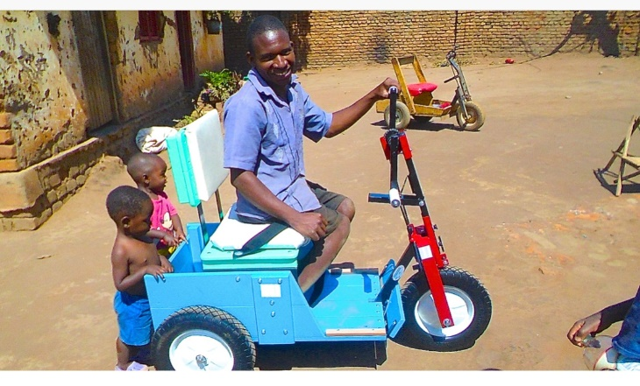

MOBILITY WORLDWIDE
SUPPLIES NEEDED:
Contribute during the month of June

TOOLS
6" Adjustable Wrench
6" Locking Pliers/Vice Grips
7/16" Combination Wrenches

PAINT SUPPLIES
Black Gloss Metal Spray Paint
Latex Exterior Paint (Semi-Gloss or Satin)
(No interior paint, please! Lighter colors are fine for 1st coat, bright colors for 2nd coat; Partially used cans are ok)
3-4" Paint Brushes

WOOD SUPPLIES
2x4's (14" or longer)

PACKAGING SUPPLIES
2-3"-wide Packaging Tape
15 oz Soup Size Cans (empty, clean, lid removed)

